# **hMail Server For Email Testing [Development Purpose]**

**hMail Server Installation:**

1. Download hMail from <https://www.hmailserver.com/download>. Choose latest version.
2. Run the installer.
3. Click next until select components. Check both options and click next.

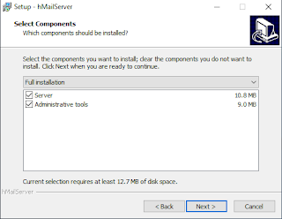

1. Choose "Use built-in database engine (Microsoft SQL Compact) and click next.

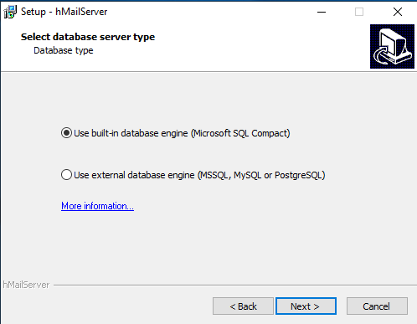

1. Click next until "hMailServer Security". Enter any password you want as long as it is easy to remember and click next. **E.g:** Passw0rd1

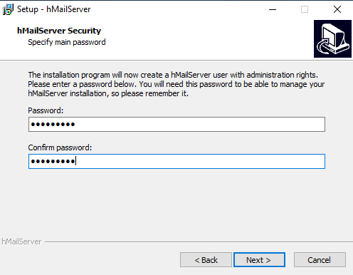

1. Click Install.

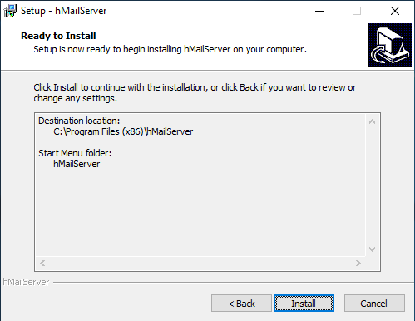

1. Finish.

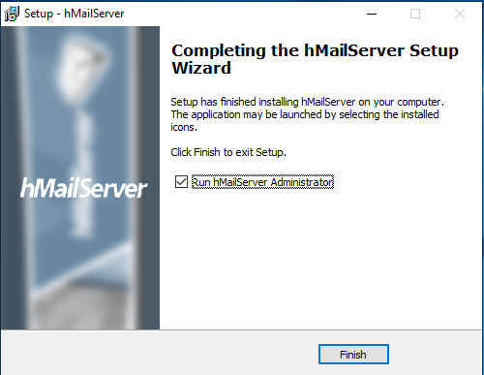

**hMail Server Configuration:**

1. Open hMailServer Administrator.

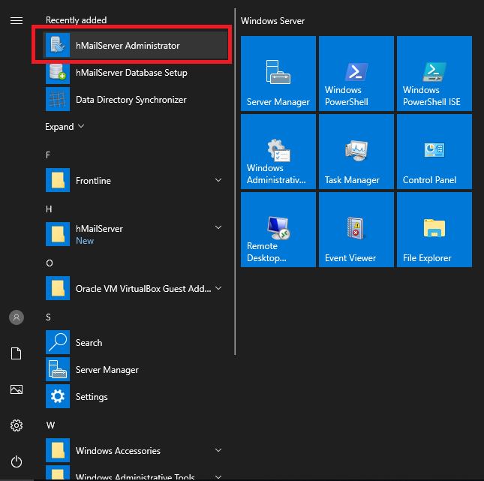

1. Choose the default mail server and most importantly set it to "Automatically connect on-startup".

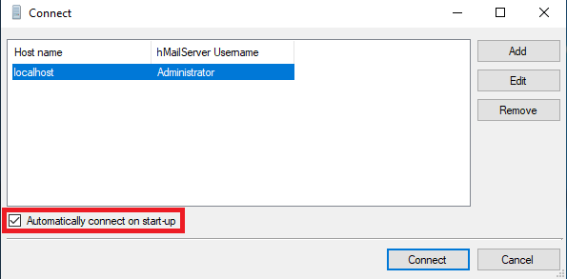

1. Enter the password based on the step number 5 at **hMailServer Installation**.

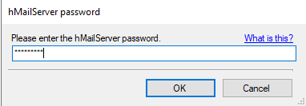

1. Go to Settings > Advanced > Auto-ban. Disable the box and save.

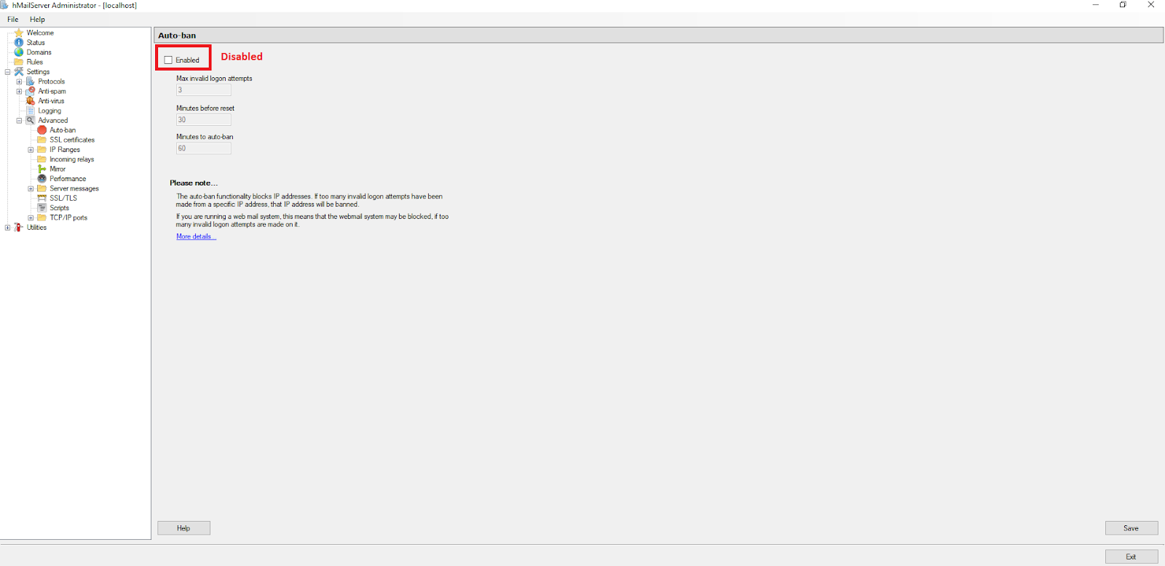

1. Go to Domains and click add.

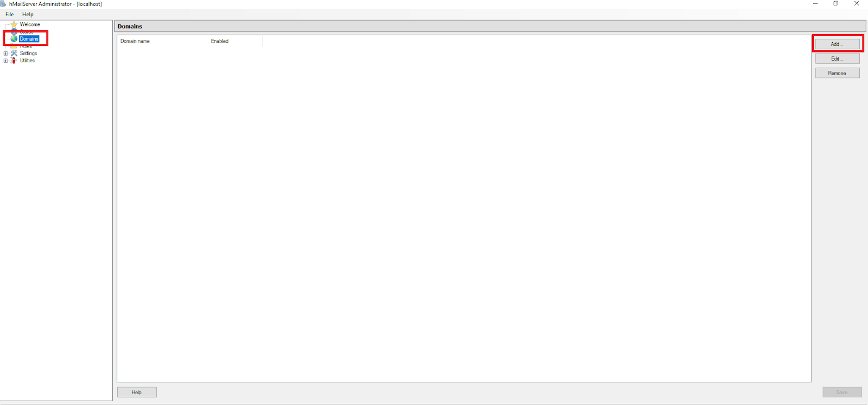

1. Enter any name and save.

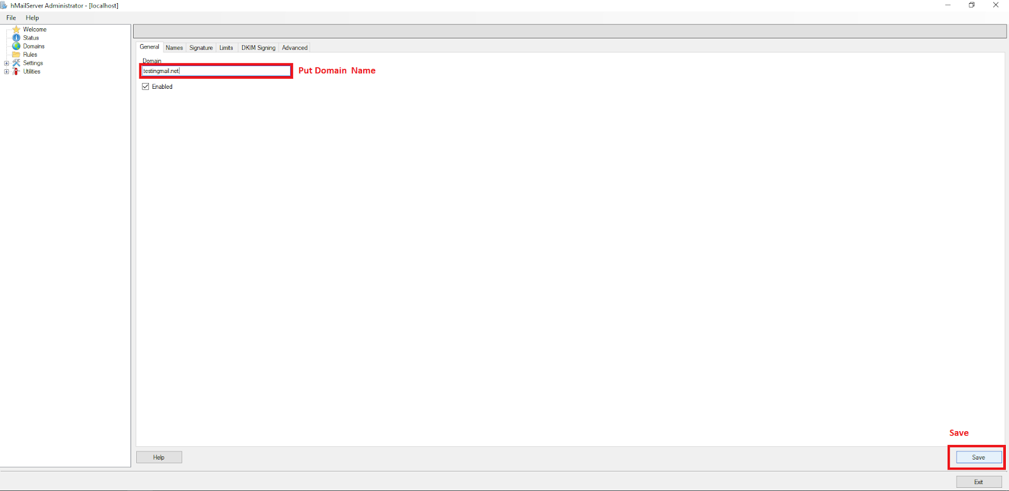

**hMail Create User:**

1. Go to Domains > Your Domains (Eg:testingmail.net) > Accounts.

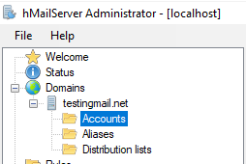

1. Add 3 Users (Admin, Requester, Approver). After that, click Save. Make sure after save, go to step 1 again to avoid new account name rewrite existing account.

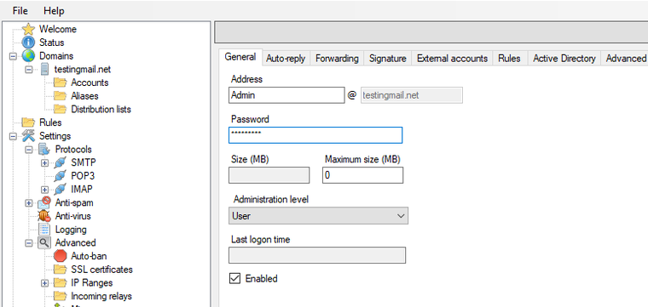

**hMail Host Configuration Setting:**

1. hMail host configuration setting example.

|  |
| --- |
| 192.168.56.195 mail.testingmail.net  192.168.56.195 testingmail.net  192.168.56.195 smtp.mail.testingmail.net  192.168.56.195 pop3.mail.testingmail.net |

1. Open notepad as Administrator.

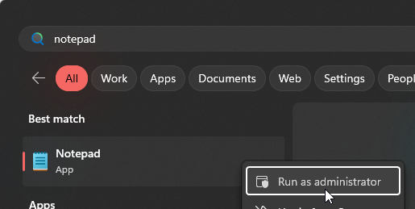

1. Click File > Open.

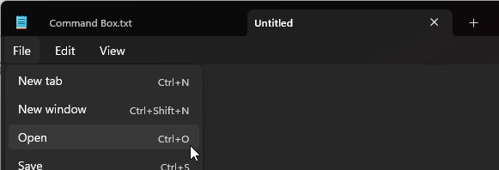

1. Go to C:\Windows\System32\drivers\etc . Change to All Files.

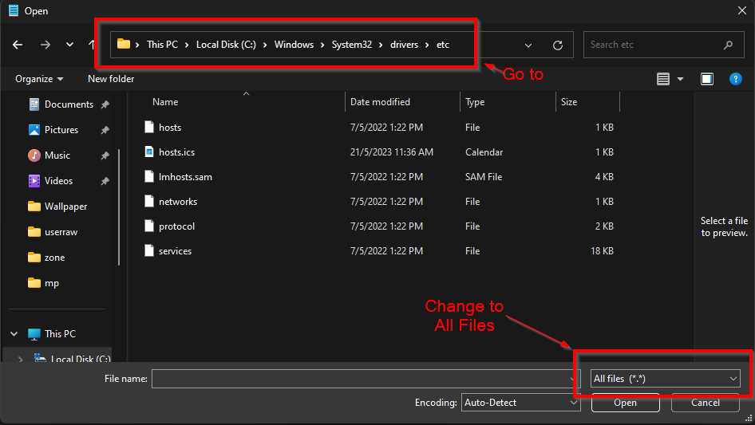

1. Open hosts.

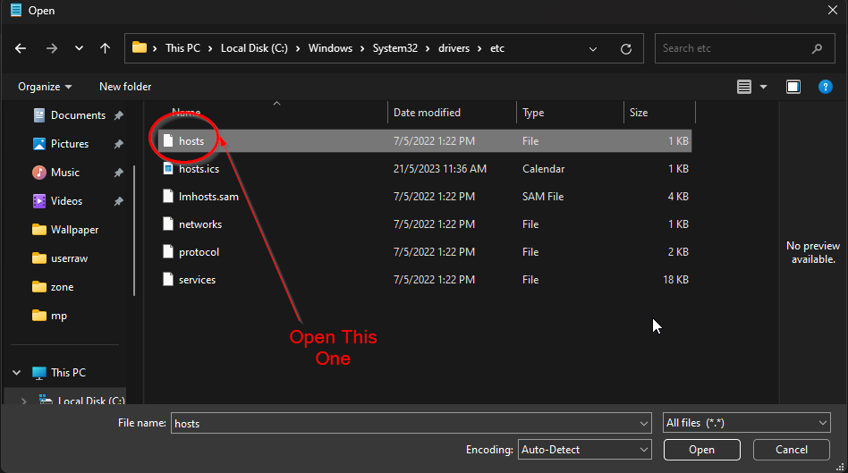

1. Copy all configurations setting from number 1 and paste it inside the hosts file.

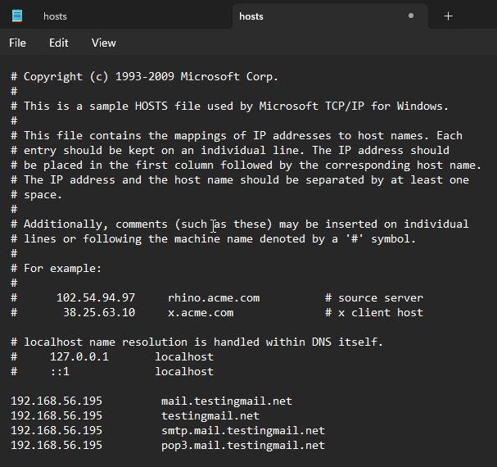

1. Change IP in the red box area to your Hmail server IP address and save it.

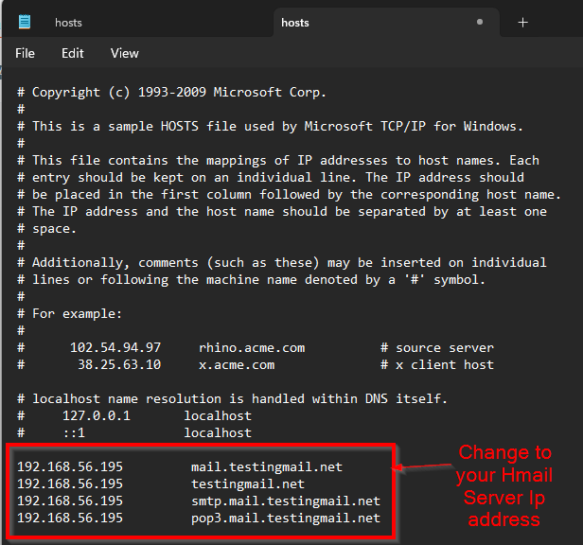

1. Please make sure that you copy and paste all hosts inside the server that need to use hMail as email communication. Example inside VM server, hMail server and VM host server.

**hMail Test Email:**

1. Make sure your hMail server open.

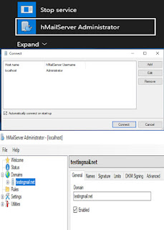

1. Install Thunderbird from <https://www.thunderbird.net/en-US/> .

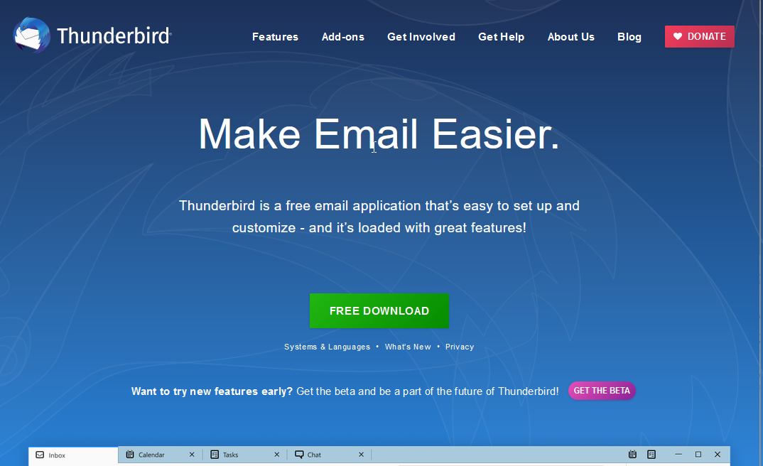

1. Use any 2 email accounts that we have created previously on hMail Server to Thunderbird application.

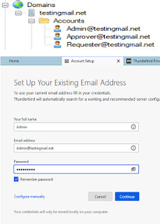

1. Chose any available configurations you preferred. For my side, I used POP3.

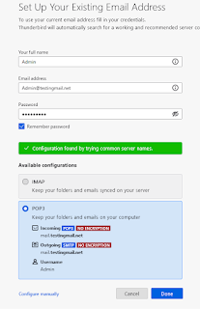

1. Check “I Understand the risk“.

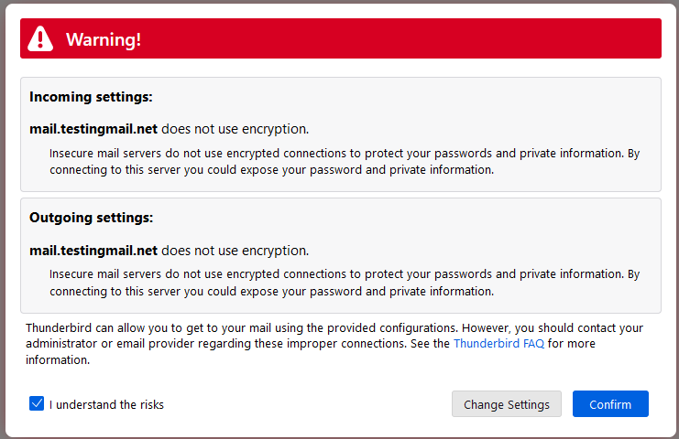

1. Confirm Security Exception.

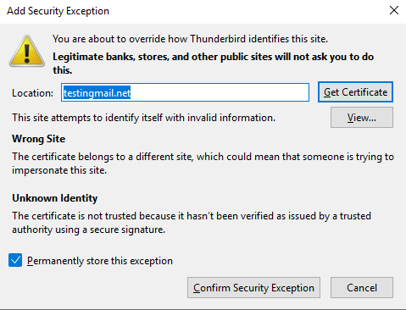

1. After that, click Finish.

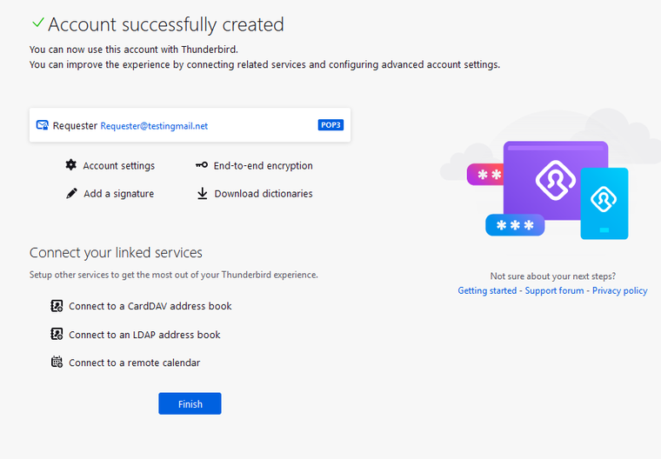

1. If you want to put another email, click the red box area.

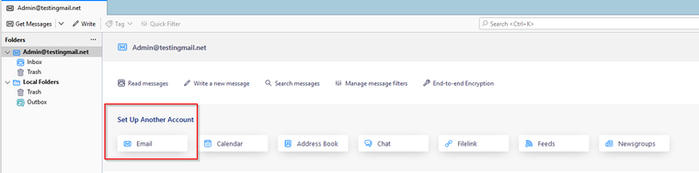

1. Now, from first email user, try to send message to second email user.

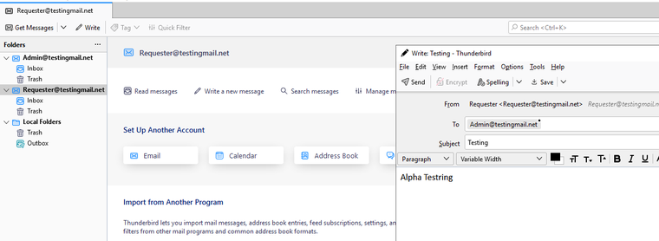

1. Click Get messages to get new email.

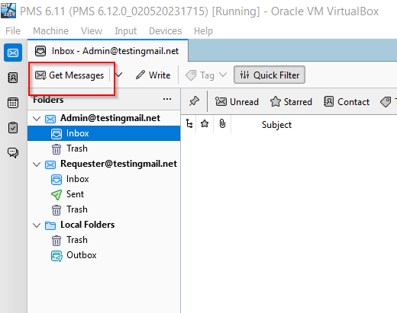

1. If it receive, means you have successfully setup your hMail server.



1. Done.